Sanday Development Trust Annual trustees report
For the year ending 31 March 2015

Sanday Development Trust Annual trustees report
For the year ending 31 March 2015

Letter from the chair, Steve Ray:
Welcome to the Sanday Development Trust Annual Report for 2014 to 2015. This is my first as chairman, and as a director, having only joined the Board at the 2014 AGM. It hardly seems possible that the 2015 AGM is now less than a month away.

A lot has happened in the last year, although much of the work may have gone unnoticed. Probably the most striking thing I have discovered is just how much has to be done to run a charitable trust, and how much effort is required to maintain what has already been achieved. To give just one example, The Sanday Heritage Centre opened in May 2014, but the final end of project did not occur until well in to 2015, requiring endless hours of paper chasing, dotting i’s and crossing t’s. Of course in reality the project didn’t really end. It will continue for as long as there are volunteers to run it. The Centre will continue to develop and evolve to meet new ideas and aspirations. More on this later.

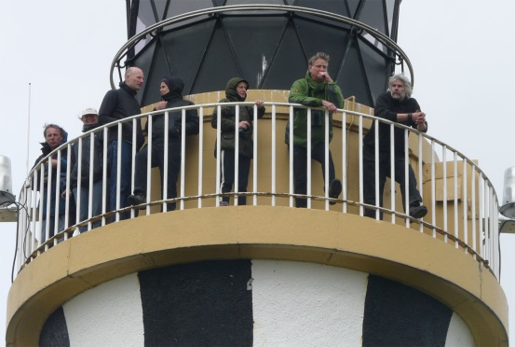
As the Heritage Centre project came to an end, it was time to review the Sanday Plan and set down proposals for the next five years. This is almost complete and I would like to pass on my thanks to all of you who took the time to respond to the questionnaire, came along to one of the drop in sessions, or just put forward your views informally. It all helps to inform the Board and set the direction for future development.
Looking out from Sanday Lighthouse

The past year has also seen some important staff changes, with a new Projects and Grants Officer, Imogen Sawyer, and recently a new Ranger appointed. Most residents will have met Imogen by now, but our Ranger has only just arrived. I would therefore like to welcome Emma Webb to Sanday and wish her all the best as she settles in to island life. I also wish to extend my thanks on behalf of the whole community, to Rod Thorne who took on the role of Ranger ten years ago, and made it in to the fabulous resource it is today. I hope he enjoys his retirement and continues to be actively involved in island life. One further appointment has recently been made thanks to funding from the Royal Bank of Scotland towards provision of skills training on Sanday. Sue Mellors is joining the Trust to develop a training programme primarily aimed at enhancing job prospects, but also covering social education. Again I would like to extend a welcome to Sue and look forward to this exciting project getting under way. Many people have spoken about the cost and inconvenience of travelling off island to access courses, so I hope bringing the training to the people will be well supported. A good uptake over the coming year could open the door to further funding for subsequent years.

I have touched on some of the work carried out over the last year, but what of the future? Community consultation confirmed the Trust’s belief that something needs to be done to revitalise Kettletoft. Lady village has benefitted greatly from the opening of the Heritage Centre, the Croft, and the reconstructed Meur Burnt Mound. Together with the Re-use Centre and leased workshop, these have brought people in to the village creating a new vibrancy and optimism. Kettletoft on the other hand is no longer the entry point for the island and has lost its purpose. The Trust has received a multitude of ideas for development within the village, and is currently formulating plans for a major project. This is at a very early stage, but we hope that in time we will be able to work with residents and existing businesses to bring the village back to life with increased prosperity. Work continues on the provision of better broadband, although we are still waiting for BT to announce its future fibre optic roll-out plans, this being the key to unlocking Government funding for local solutions. Work is also being carried out to promote the status of the Heritage Centre to museum. If successful Sanday might be able to display treasured items such as the Appiehouse Stone and Whalebone Plaque, and could negotiate on their eventual return.

The Trust continues to work on your behalf, but cannot work in isolation. It needs your support and I urge every Sanday resident to think about becoming a member. Membership is free and can make a huge difference as it demonstrates to potential funding bodies that there is community support. Why not come along to the AGM on the 3rd November to learn a bit more about the Trust’s work? I look forward to seeing you there.

Steve Ray, chair, Sanday Development Trust

Summary of main activities undertaken in the year from April 2014 to March 2015

1. Renovation of the nineteenth century ‘Temperance Hall’ building was completed. This was a major project supported by funding from Orkney Islands Council, LEADER, SSE/Sanday Community Council and a bequest from the Horne brothers. The project also depended on a huge contribution from community volunteers. Volunteers were involved with all stages of the project including planning, provision of labour and designing and equipping the heritage centre which was a main feature of the project.
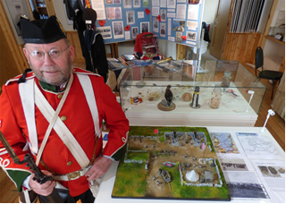
The project dominated trust activity for the second year. Building work was completed early in the year and the part of the building designated for the new heritage centre was decorated and fitted, opening for visitors at the beginning of the summer season in May. Work on the heritage centre continued throughout the summer season and into the winter. The decision was made to ensure that the heritage centre was equipped to museum standard and that the experience of visitors should be of the highest quality. Considerable research was carried out by volunteers to decide on the best display equipment. A part time employed post was created during the summer season in order to assist with looking after displays and cleaning the heritage centre. The appointed custodian/cleaner also assisted with running the shop, greeting visitors and answering their questions and cataloguing exhibits. In addition to the heritage centre, two business units were created, one for the reuse centre and one to be let for public use. The reuse centre opened in its new home in November 2014 and the second unit was let to a small business in January 2015.
New Colliness battery model with maker, at the Sanday heritage centre
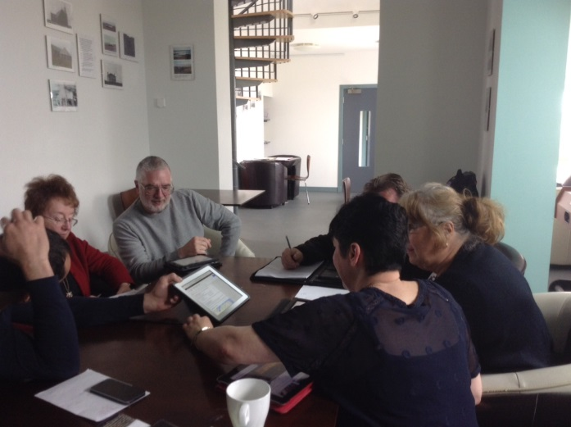
2. Heilsa Fjold, the youth and community centre, was further developed as a venue for a variety of activities under the guidance of the part time centre manager. Computers, wifi and office, audio visual and game equipment were available for use by visitors as well as a variety of pleasant spaces for events or just for dropping in.
Youth drop-in sessions were a regular feature, run by the drop-in supervisor. A trial period to enable older children to drop in unsupervised was run. Children were able to use the facilities during youth club sessions and considerable use was made of the sound mixing equipment.
The café became more established, opening 2 to 3 times a week depending on the season, encouraging regular use of the centre by a good number of people.
The Sanday Experience bus tour, run by Sanday Enterprises Community Interest Company, a trading subsidiary of the trust, made use of the venue and café.
IT training at Heilsa Fjold
A number of training events were held, IT training for people with minimal experience proving particularly popular.
Occasional use of the building was made for meetings, social events, catering and veterinary visits.
New initiatives included farmers markets and a ‘swishing shed’ for the exchange of clothing.
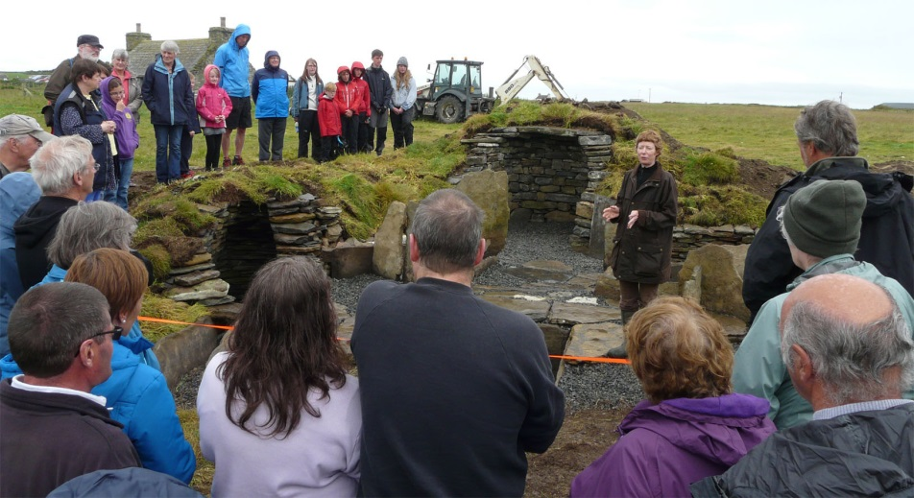
3. The heritage group supported the heritage centre and croft house with many hours of voluntary work and fund raising events. The group also hosted an initiative from the archaeology department at the University of St Andrews to move a burnt mound, uncovered on the beach at Meur, to a safe, central location where it could be easily viewed by visitors. The burnt mound was carefully removed from its original coastal site and reconstructed next to the heritage centre and croft, an ideal position to display some of Sanday’s earliest built heritage.
The relocated burnt mound, part of Sanday’s ancient heritage
4. The Sanday ranger service continued to provide access to Sanday’s natural heritage for islanders and visitors with a series of guided walks and talks throughout the year. Informative talks and outings were arranged for school children, girl guides and visitors on the Sanday Experience bus tour. A number of illustrated articles were provided for periodicals. The extremely popular seal cam was operated once again and new this year was a display for the heritage centre. In addition the ranger service provided a link to many partners looking for an environmental perspective on issues under consideration.
5. The reuse and recycling group were pleased to be able to reopen the reuse centre in its new home at the Temperance Hall following the closure forced by storm damage. The reuse centre was run entirely by volunteers; collecting, displaying and selling donated goods.
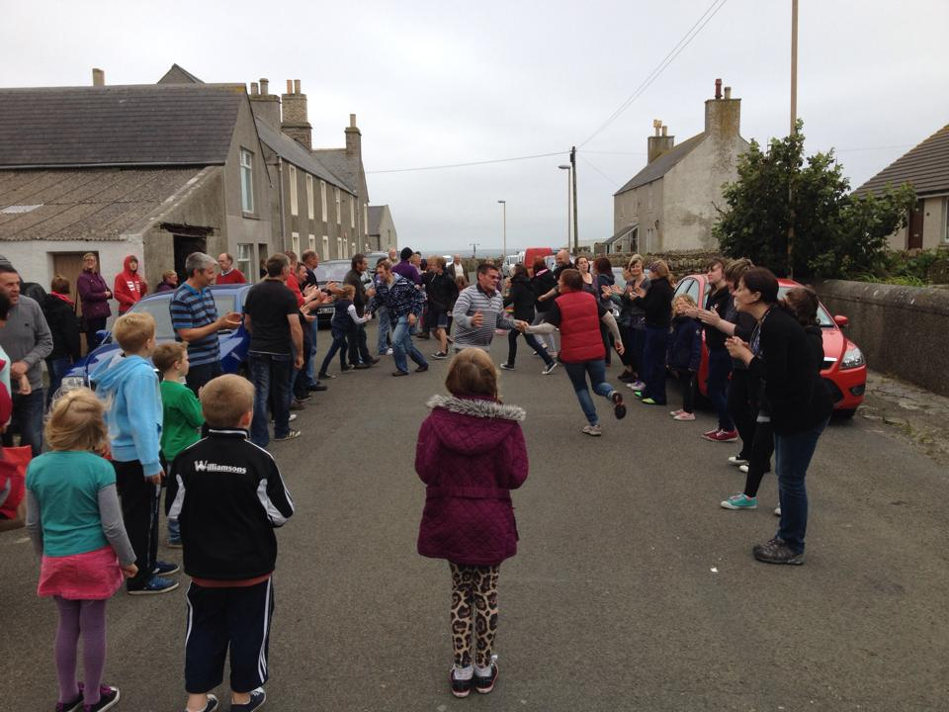
6. The Sanday Soulka continued as in previous years, running three weekend mini festivals during the summer months promoting island arts, crafts, and industry. Highlights included sea-angling, a home brew/wine competition and a feast of Orkney food.
'Strip the willow', Sanday Soulka
7. The bus service, run by Sanday Enterprises Community Interest Company, continued to run successfully offering a daily service to meet all ferries, a once weekly route around the island to include shops and banks and a weekly ‘Sanday Experience’ tour for visitors.
8. Sanday Renewables Community Interest Company, one of the trust’s trading subsidiaries, supported the trust by contributing to the cost of the trust infrastructure and assisting with cash flow to enable retrospectively funded projects to go ahead.

Summary of the main achievements:

1. Management of community land and assets for the benefit of the community

The renovation of the Temperance Hall brought an old building, an important part of Sanday's heritage, back in to use and secured it as part of Sanday's future. The heritage centre which was created there will be accessible to islanders and visitors. The maintenance of the croft heritage centre was similarly beneficial. During the 2014 summer season 921 visitors signed the book in the heritage centre and 622 visitors signed the book in the croft.
The youth and community centre at Heilsa Fjold provided a pleasant and well equipped venue to islanders and visitors.
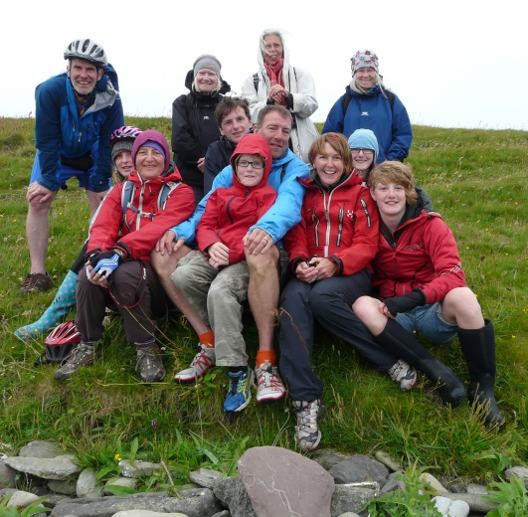
2. Facilities for recreation and leisure time occupation available to the public at large
Return from ranger trip to Holms of Ire
Heilsa Fjold was available for many uses including youth drop-in, youth club meetings and use of the sound equipment, laptops, wifi and game equipment. There was also a regular café, plus occasional social events, meetings, training courses and farmers markets. The office for the Development Trust was located at Heilsa Fjold and the coastguard located their office and rescue vehicle safely and securely on the premises. Feedback from users was extremely positive. A part time centre manager was employed to help maximise use of the centre by the community.
The heritage centre, croft and reuse shop also provided opportunities for varied social interaction.
The bus shopping service continued to benefit people with transport difficulties enabling them to get out at least once a week for shopping and meeting other people.
The Sanday Soulka group organised three weekends of varied entertainment.

- Advancement of education and promotion of opportunities for learning

There were opportunities for all age learning at the heritage centre and croft through themed displays and educational events, for example displays and talks featuring Sanday and Orkney during the first world war and talks on Orkney dialect.
Regular IT training events at Heilsa Fjold were much appreciated, particularly by older members of the community.
The ranger carried out a programme of environmentally themed educational events for islanders and visitors and also for school children.
IT facilities at Heilsa Fjold were used by members of the community of all ages for research and accessing webinars and other on line educational resources.

- Preservation and restoration of the environment

The ranger continued to ensure that environmental issues were considered.
The bus service continued to provide a year round service to and from the ferry, reducing the number of vehicles on the island roads.
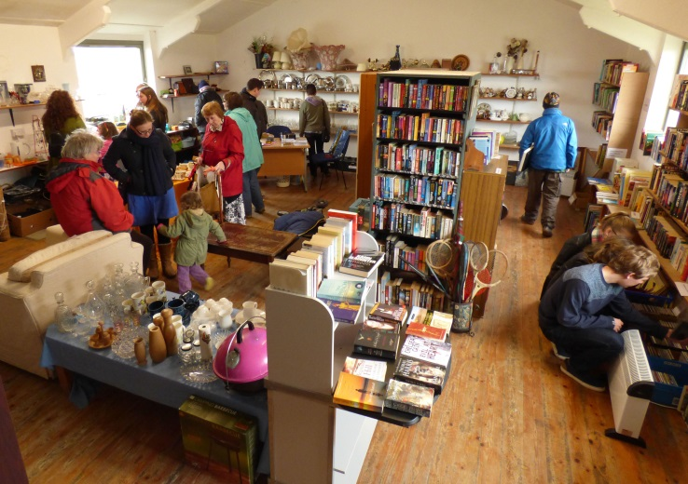
The resiting of the burnt mound, a part of Sanday’s ancient heritage, ensured that this important piece of archaeology will be preserved for future generations.
Shoppers at Sanday's reuse shop

5. Encouragement and stimulation of volunteering in the community

Members of the Trust and others put many hours of volunteer labour into supporting and running the heritage centre, croft and reuse shop.

6. Relief of poverty

Six part time posts were supported by the Trust and a number of casual employment opportunities were created through the year.
The reuse centre continued to redistribute essential household goods. The Development Trust and bus service provided part time employment to eight people, casual employment opportunities and used local business services whenever possible.
IT facilities at Heilsa Fjold were used by members of the community, for example for job searching, creation and printing of CVs and application forms and so on.

